Upfinity  
  
Upfinity was founded on September 21st 2021 with the goal of creating a fun and innovative ecosystem where all aspects are built with community rewards in mind. We noticed that there were very meme ecosystems or very serious ones, but not one that incorporated the best of both worlds and we wanted to always reward our community for choosing us over everything out there.  
  
But being fun and innovative wasn’t enough for us, that’s why our token is powered by a unique smart contract with the capacity to adapt. It is possible for us to add and implement any new trends immediately, allowing our community to benefit from whatever is hot on blockchain at the moment.  
  
Gamified and innovative tokenomics, NFTs with utilities, play to earn games, all sort of launchpads, a metaverse, you name it, we have or will have it.  
  
The Upfinity metaverse  
  
Intro:  
  
Upfinity was a tech company that through R&D discovered how to control nuclear fusion and later on how to manufacture micro size reactors, making unlimited energy with 0 emissions a reality. From coffee machines to whole cities, everything is powered by Upfinity™ reactors. 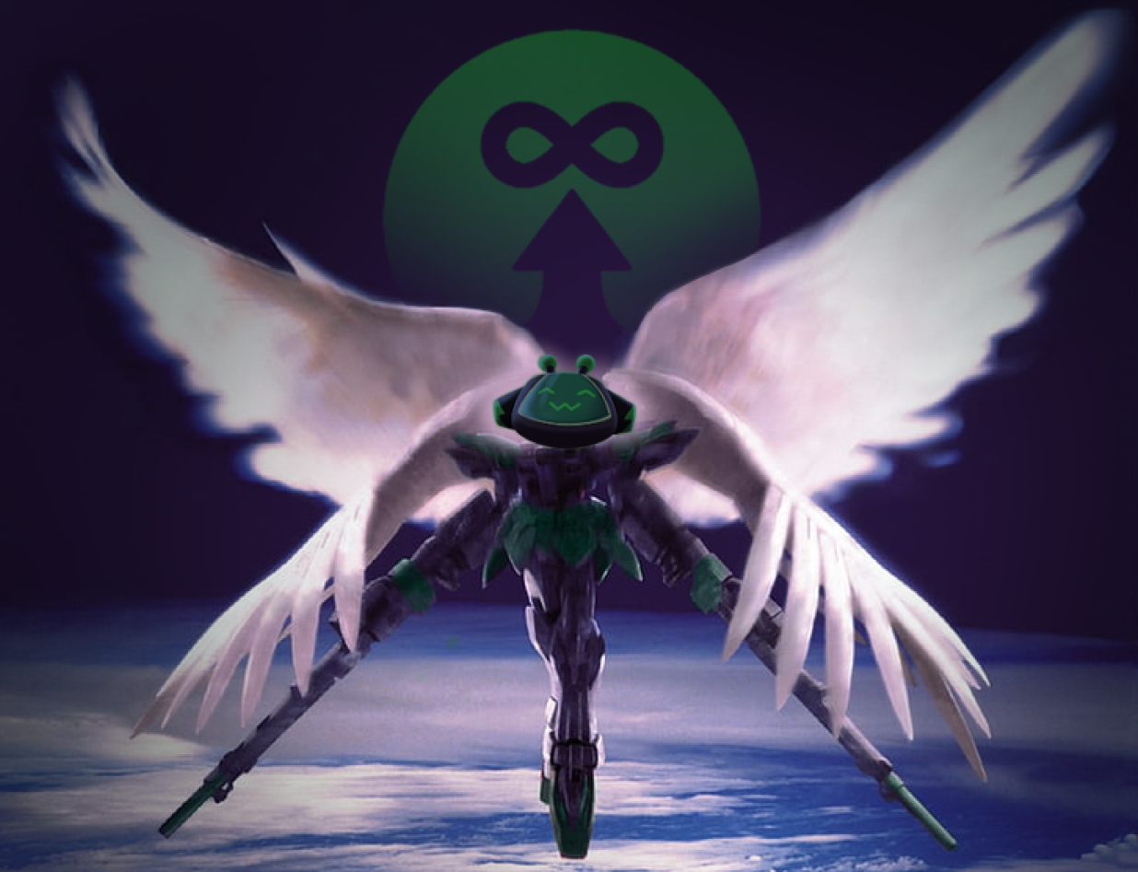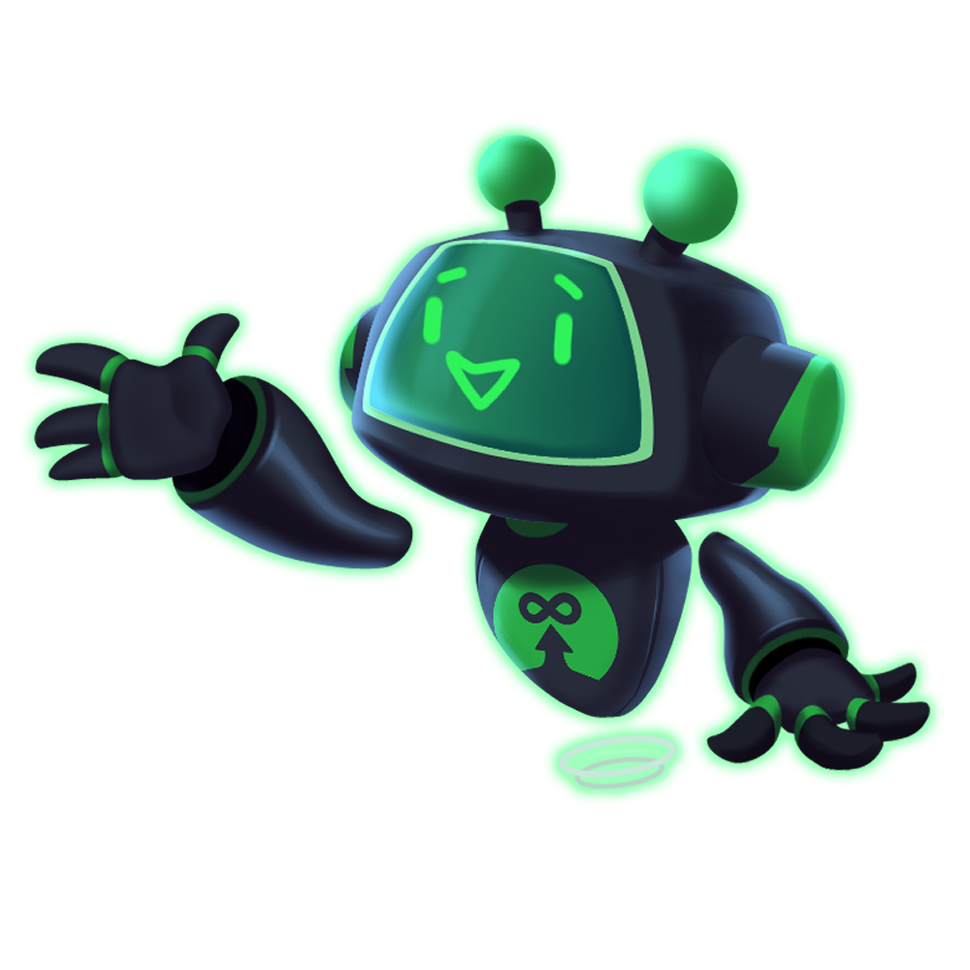  
*Upgraded Personal Framework “AIA“ U.P.F AI Assistant*   
  
Through their U.P.F (Upgraded Personal Framework) Initiative they made life in the moon possible and now from "The Upfinity" moon base they are looking to open the gate to what's beyond for all human race  
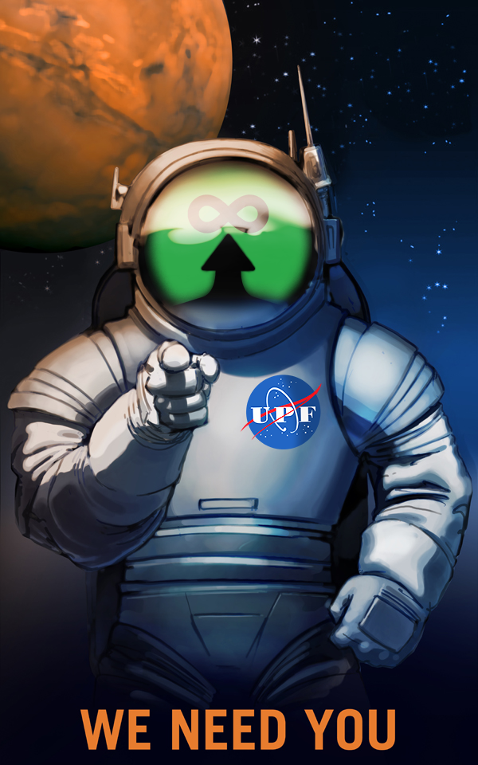  
*“Going beyond” recruitment campaign*  
  
Aside from space exploration, Upfinity is involved in many events and community activities.   
One of the most popular is “Upfinity wars” a competition where contestants put to test their determination and skills riding rocketcycles, most of them from major manufacturing companies. Is sponsored by Upfinity  
  
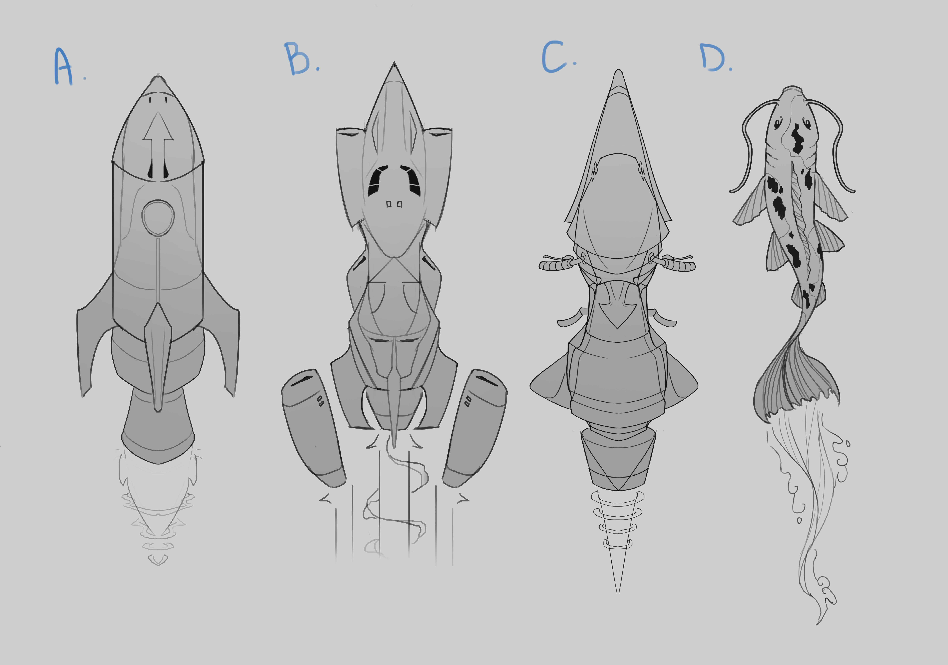  
*Prototypes display*  
  
  
Introducing our two main characters  
  
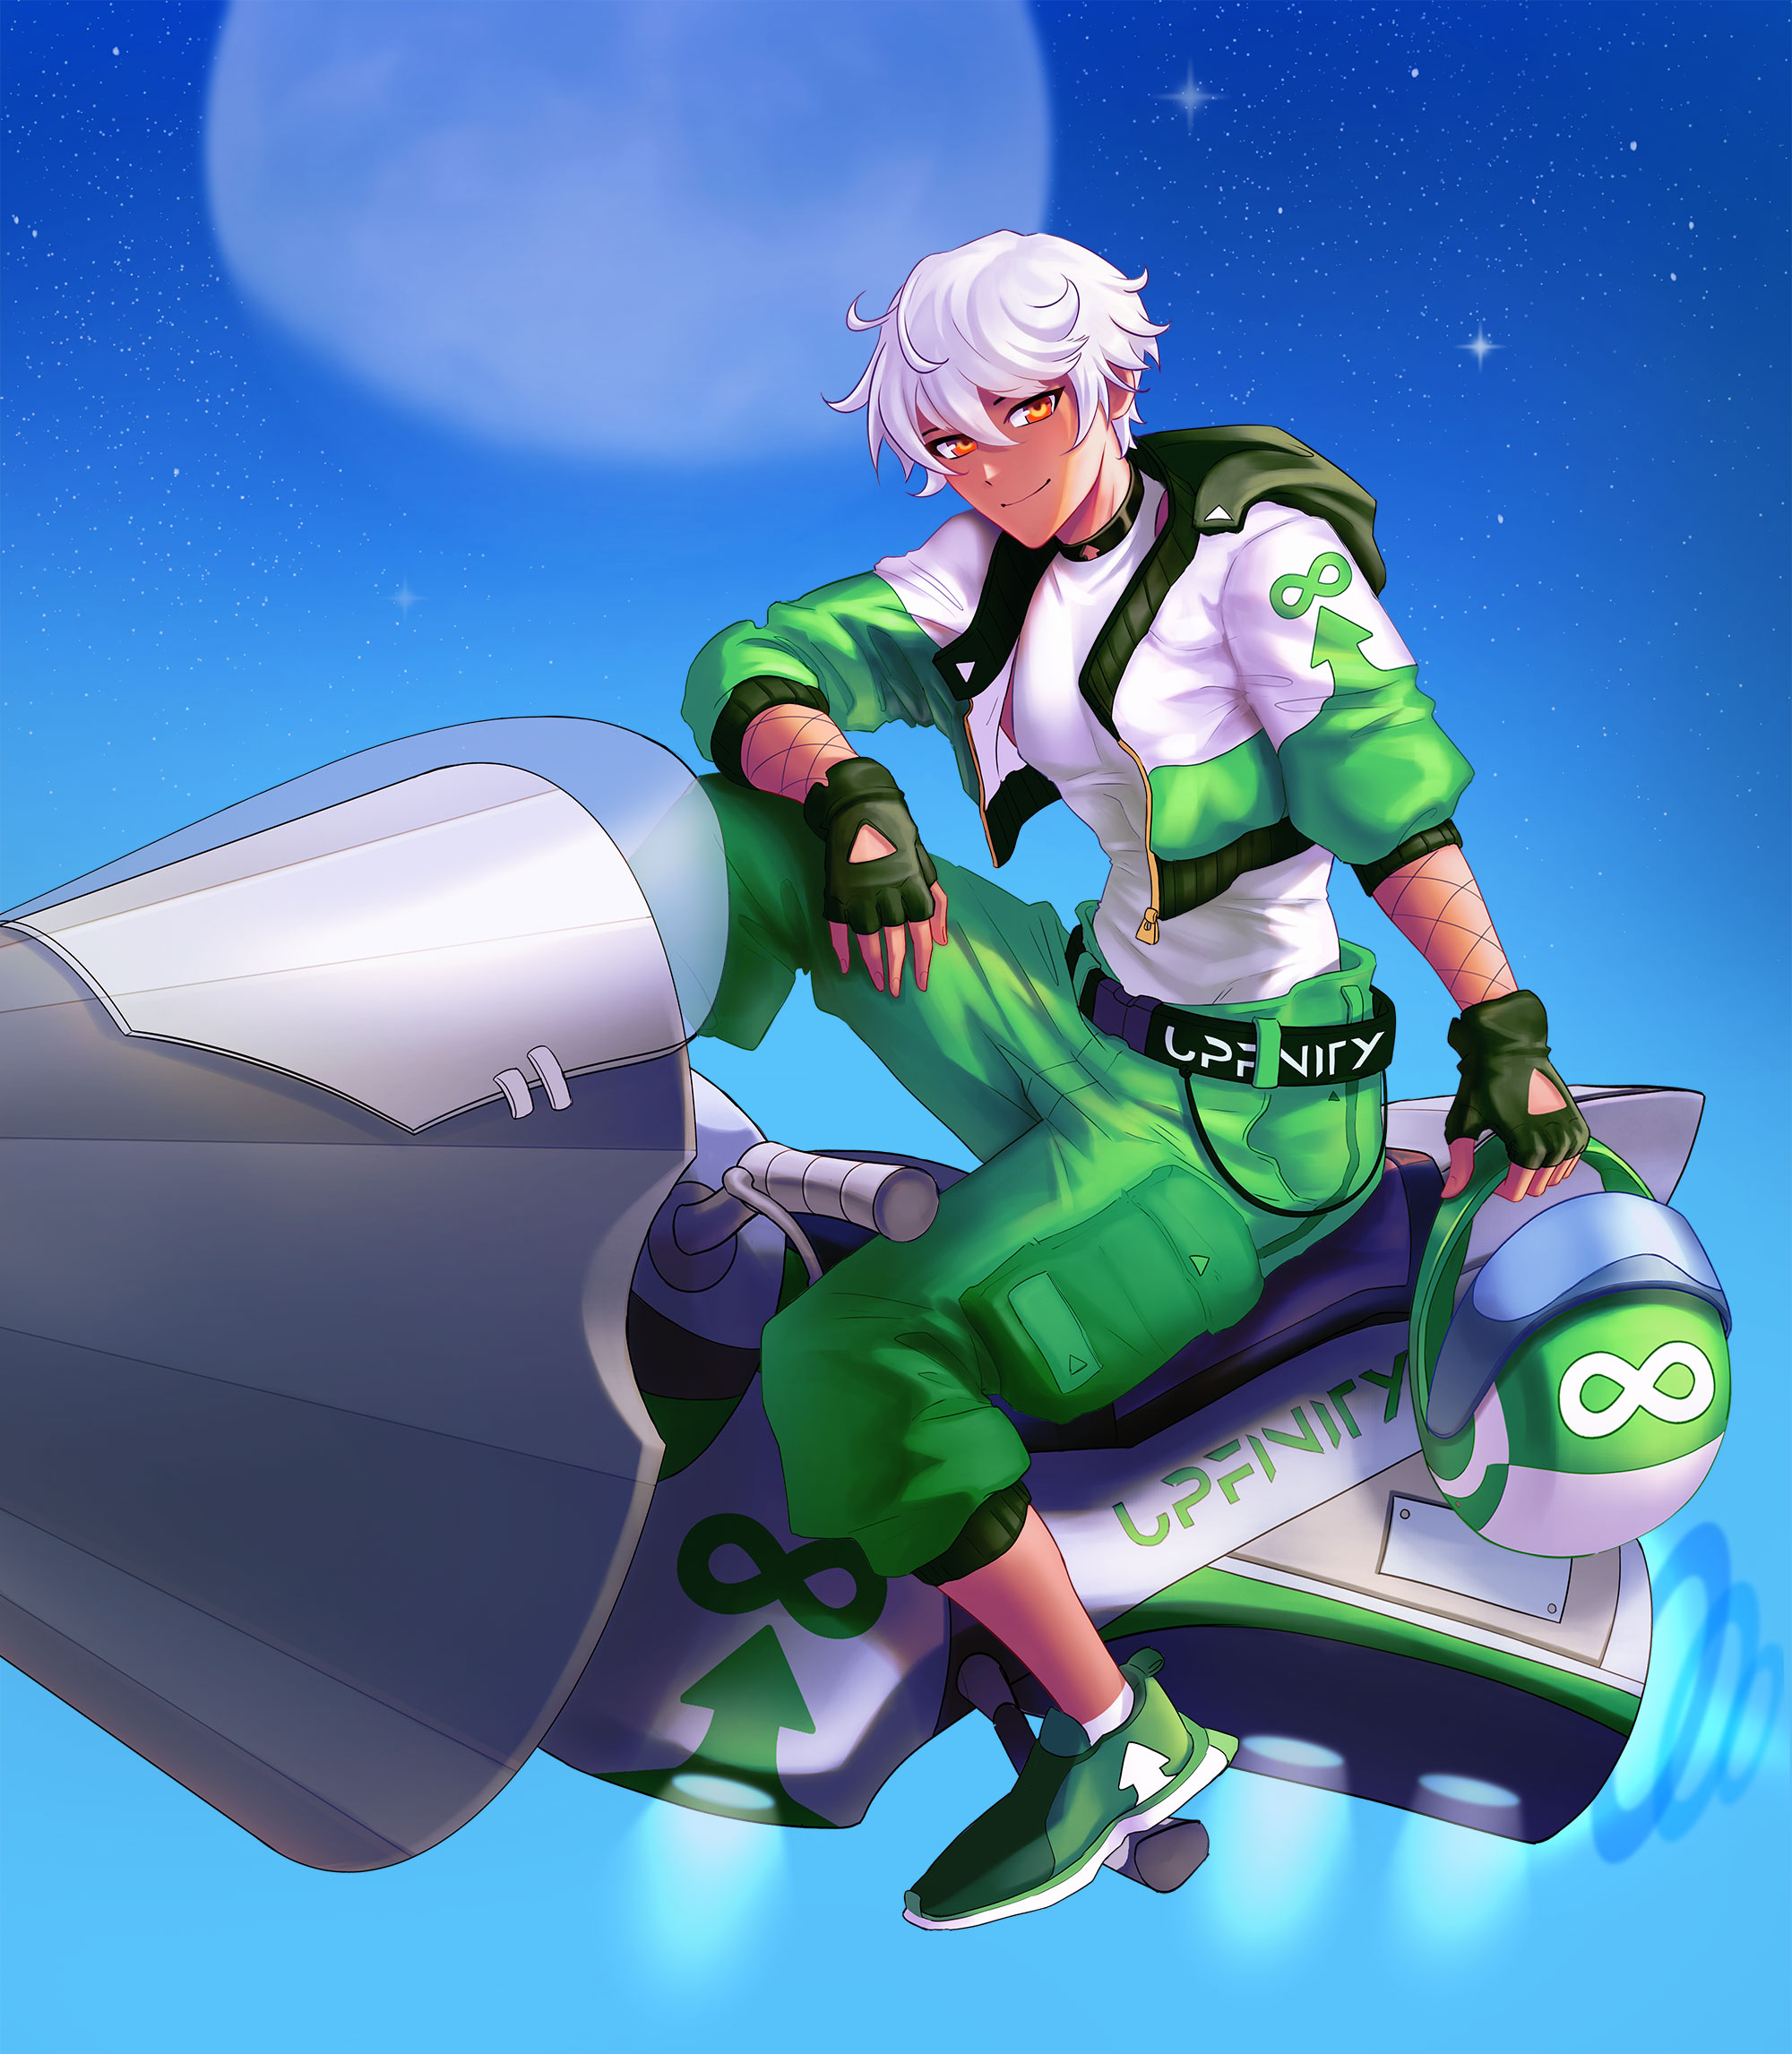  
*“Isaac Nucla”*

The Competitive heir to the Nucla corp, one of the top rocketcycle manufacturers. Raised on the rocket Isaac has been a driver ever since he could walk. From experimental tech to top of the line production items he has tested it all. Money, Fame, Girls… None of that matters. All he has on his mind is open skies in his rear view.

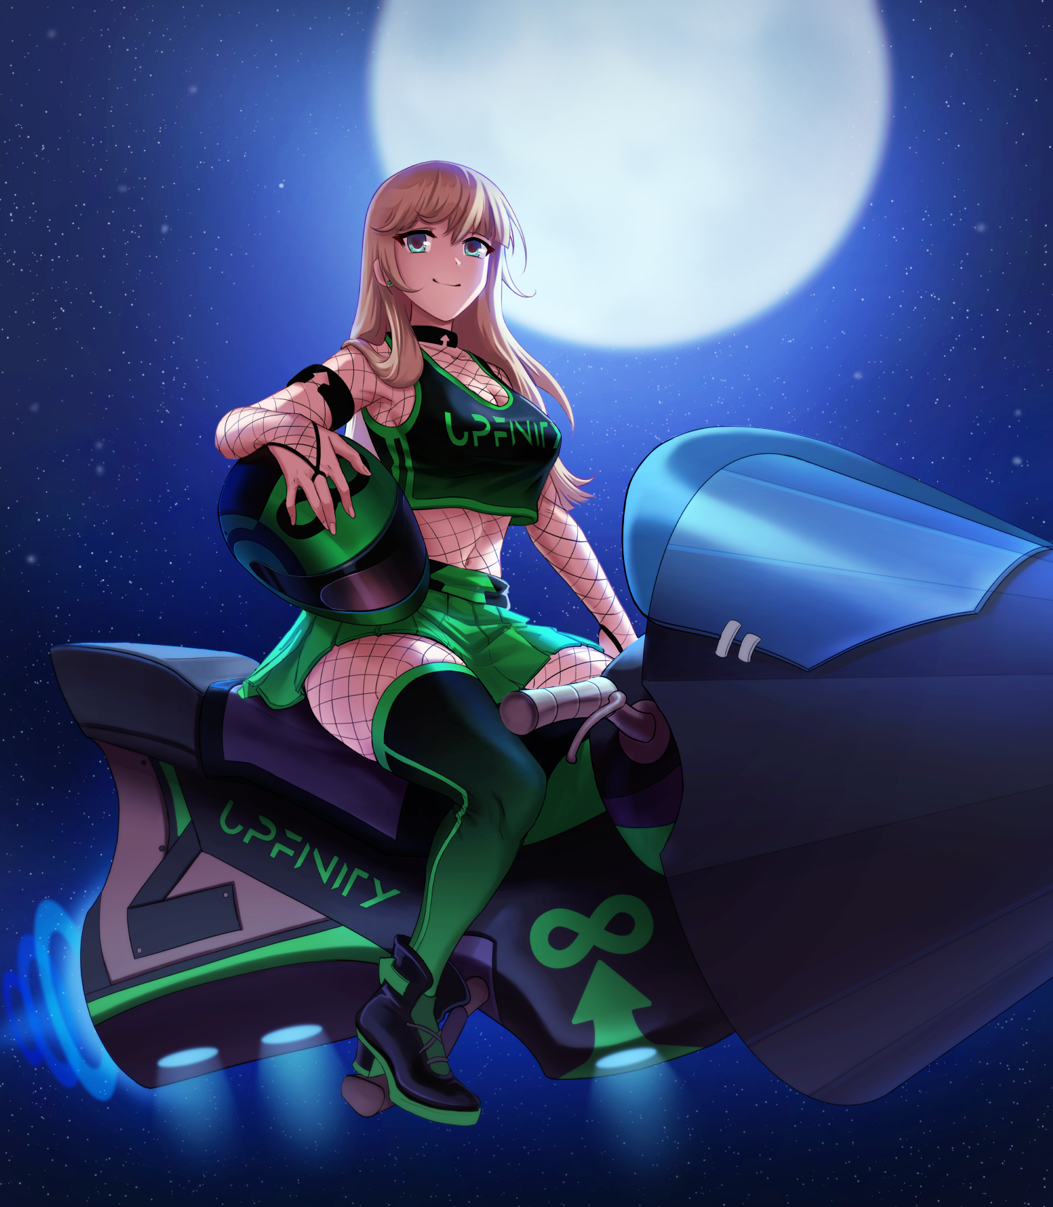  
*"Nera Moon”*

Often referred to as Captain Nera. This scrappy, bubbly girl is the head of the GR (Galactic Rocketeers). An outlaw group that rules the dark side of the moon.  
Since a baby she grew up with nothing and fought for everything. Now she has an empire of her own and takes whatever she wants. Cross her and it may be the last thing you do.